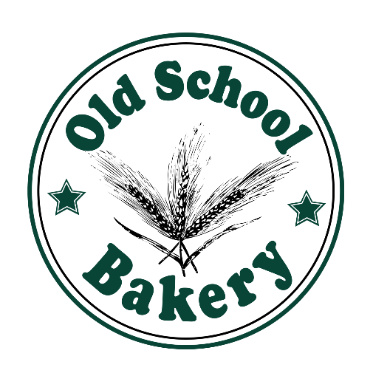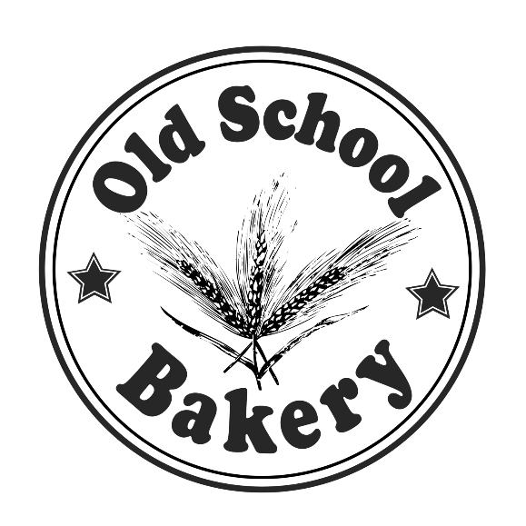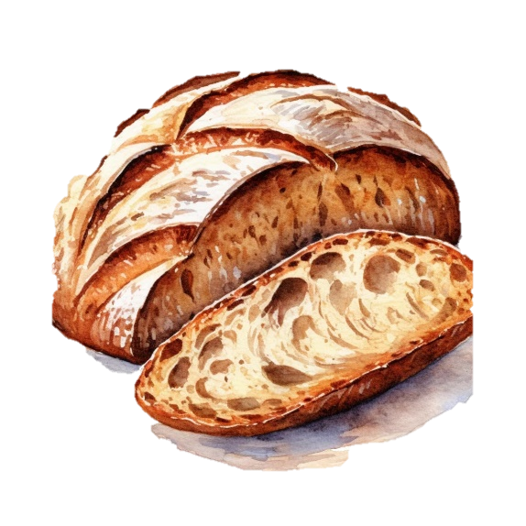

**WHY CHOOSE US?**

* **We’re affordable**
* **We’re near by**
* **We have quality products**

Use Promocode uw125x to get a 10% discount!

CAKE

Best Cake in Town

Delicious